**GitHub Repository Management Guide**

**Introduction:**

This report provides a comprehensive guide on various GitHub repository management tasks. We will walk through the process of creating a GitHub repository, performing check-ins (commits), checking out code, working with branches, merging changes, deleting repositories, renaming repositories, and updating repository settings.

**Table of Contents:**

1. [Creating a GitHub Repository]

2. [Check-In (Commit)]

3. [Check Out]

4. [Working with Branches]

5. [Merging Changes]

6. [Deleting a Repository]

7. [Renaming a Repository]

8. [Updating Repository Settings]

1. **Creating a GitHub Repository**

Purpose:

Creating a GitHub repository is the first step in managing your code and collaborating with others.

Steps:

1. Log in to your GitHub account.

2. Click the "+" sign in the upper right corner and select "New repository."

3. Fill out the repository details, including name, description, visibility (public or private), and

other optional settings.

4. Optionally, initialize the repository with a README file, and choose a license.

5. Click the "Create repository" button.

2. **Check-In (Commit):**

Purpose:

A check-in, also known as a commit, is the process of saving changes to your code in the repository's version history.

Steps:

1. Clone the GitHub repository to your local machine using **git clone <repository URL>.**

2. Make changes to your local files.

3. Stage changes **using git add <file1> <file2>** ....



4. Commit changes with a descriptive message using **git commit -m "changes occur".**



5. Push the commits to the remote repository using **git push.**



3. **Check-Out:**

Purpose

Checking out code allows you to switch to a different branch or retrieve a specific version of your code.

Steps

1. Use **git checkout <branch_name>** to switch to a different branch.
2. To create a new branch and check it out, use **git checkout -b <new_branch_name>**



1. To clone a specific branch from a remote repository, **use git clone -b <branch_name>**

**<repository_url>.**

4. **Working with Branches:**

Purpose:

Branches enable parallel development and isolation of features or bug fixes.

Steps

1. Create a new branch with **git checkout -b <new_branch_name>.**

2. List branches using **git branch**.

3. Switch to an existing branch with **git checkout <branch_name>.**

4. Delete a branch using **git branch -d <branch_name>.**



5. **Merging Changes:**

Purpose:

Merging combines changes from one branch into another, often used for integrating feature branches into the main branch.

Steps:

1. To merge changes from one branch into another, **use git merge <branch_name>.**

1. Complete the merge with git merge --continue.



6. **Deleting a Repository:**

Purpose:

Deleting a repository permanently removes it from GitHub.

Steps

1. On the GitHub repository page, go to "Settings."

2. Scroll down to the "Danger Zone" section.

3. Click "Delete this repository."

4. Confirm the repository name.

5. Click the "I understand the consequences, delete this repository" button.



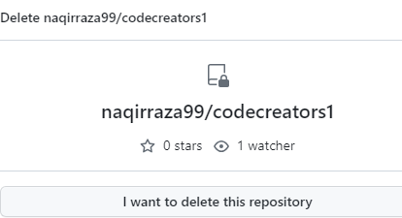

7. **Renaming a Repository:**

Purpose:

Renaming a repository helps to maintain clarity and organization in your GitHub account.

Steps

1. On the GitHub repository page, go to "Settings."

2. In the "Repository name" field, enter the new name.

3. Click "Rename."

8**. Updating Repository Settings:**

Purpose:

Updating repository settings allows you to configure various aspects of your repository, including collaborators, access, and integrations.

Steps:

1. On the GitHub repository page, go to “Settings.”

2. Navigate to the relevant sections to update settings like collaborators.

3. Make your desired changes and save them.

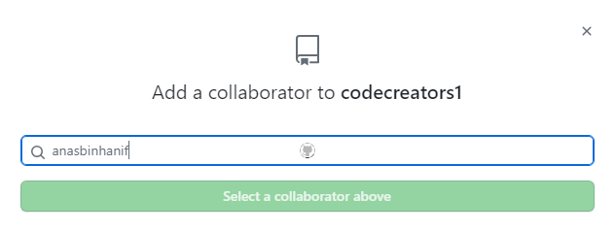

**Conclusion:**

This GitHub repository management guide covers essential tasks, enabling you to create, manage, and collaborate on repositories efficiently. By following these steps, you can streamline your development workflow and make the most of GitHub's powerful features.